# Lab 2: HTML Tables & Forms

1. Open the starting code and create an HTML table that displays your weekly schedule in section 1:

|  |  |  |  |  |  |
| --- | --- | --- | --- | --- | --- |
|  | Sunday | Monday | Tuesday | Wednesday | Thursday |
| 8:00 – 9:00 |  |  |  |  |  |
| 9:00 – 10:00 | Course A |  | Course B |  |  |
| 10:00 – 11:00 |  |  | Course A |  |  |
| 11:00 – 12:00 |  |  |  |  |  |
| 13:00 – 14:00 | Course C |  | Course C | Course B |  |
| 14:00 – 15:00 |  |  |  |  |  |
| 15:00 – 16:00 |  |  |  |  |  |
| 16-00 to 19-00  (Extracurricular) | Soccer |  | Ping-pong |  |  |
|  |  |  |
|  |  |  | Swimming pool |  |

1. Exercise 2: Forms
2. In section 2 of the starting code, create the following form with HTML5 data validation:

* 1. Include this CSS code in the head section of your html document to test the effects of data validation:

<style>

input:valid {

background-color: palegreen;

}

input:invalid {

background-color: lightpink;

}

</style>

* 1. Every input element must be linked to its label using the **for** attribute.
  2. Every input element should have a name attribute.
  3. “region” can be one of the KSA regions (Mecca, Riyadh, Eastern Region, Asir, Jazan, Medina, Al-Qassim, Tabuk, Ha’il, Najran, Al-Jawf, Al-Bahah, Northern Borders Region).
  4. All fields are required except “website or domain name” and “project description”.
  5. Phone number must contain only numbers. It must contain at least 10 digits, at most 14 digits. You can use HTML pattern attribute:

 <input type="text" … pattern="[0-9]{10,14}"… >

* 1. Use the title attribute of the input element to display a tooltip message informing the user about the expected input when he hovers over the input element:

.. title="10 to 14 digits"

* 1. Zip code must only contain digits and be no longer than 6 digits.
  2. Last name and first name can only contain alphabetical characters, no more than 30 each.

Finally, verify the data elements sent to the server by opening the developer tools:

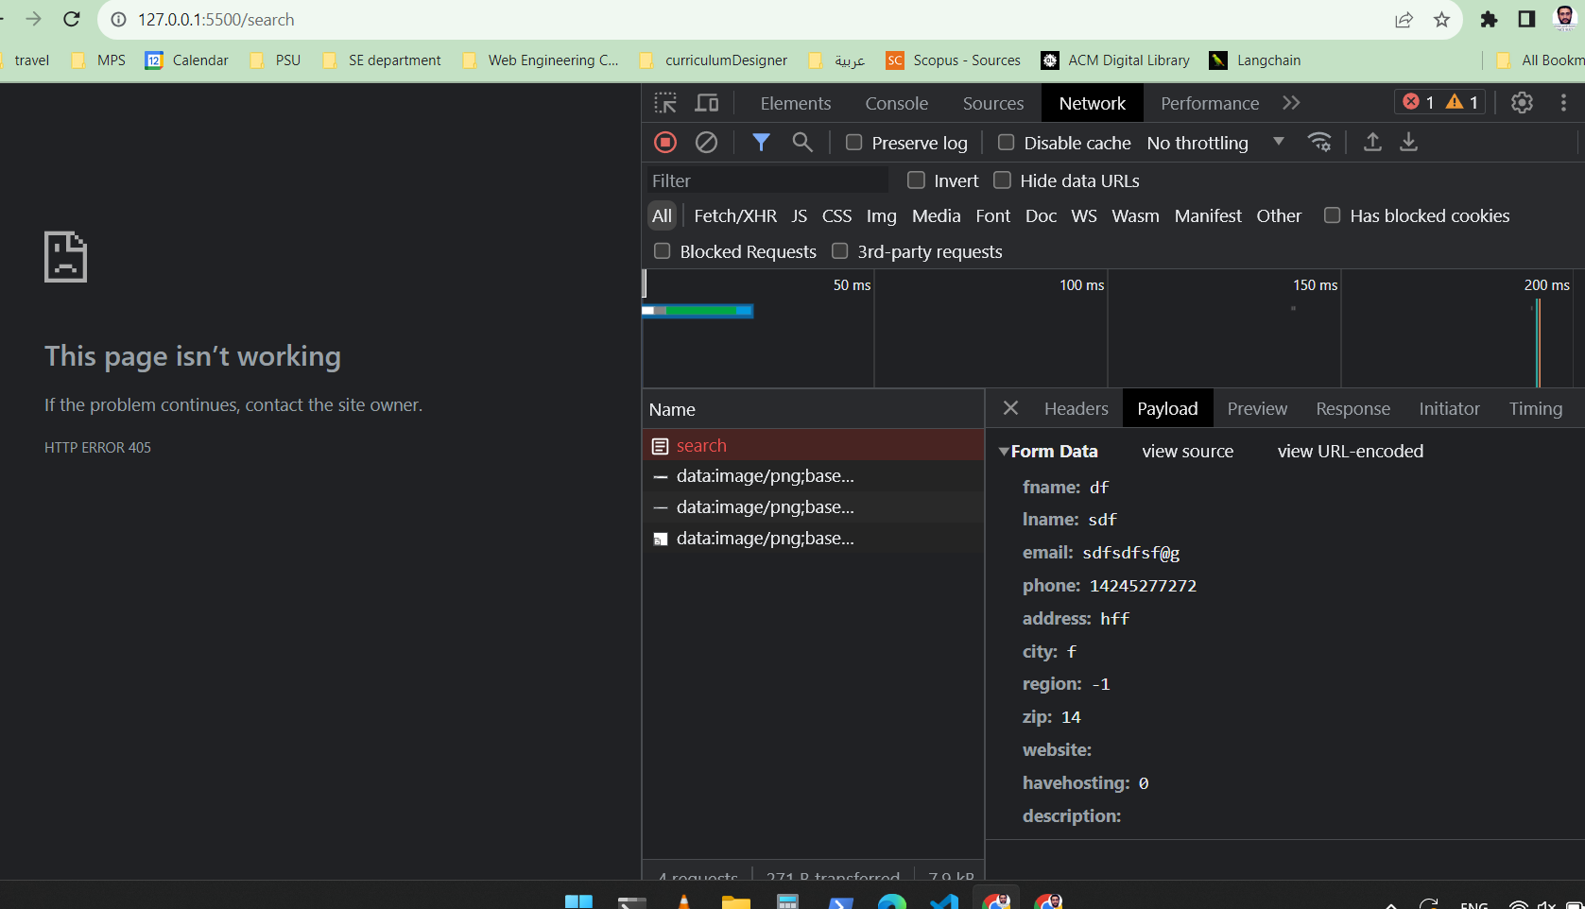

END.